**CAT 1 Advances in Web**

1. **Write a java script function that allows your lecturer to enter assignment one , assignment two Cat and final exam marks for 20 students, catch all possible errors that can possibly happen. Call the function using the click event of a command button. 15 marks**

Index.html

<!DOCTYPE html>

<html>

<head>

  <title>Student Marks Entry</title>

  <style>

    body { font-family: Arial; margin: 20px; }

    input { width: 80px; margin: 5px; }

    .student-row { margin-bottom: 10px; }

    .error { color: red; }

  </style>

</head>

<body>

<h2>Enter Marks for 20 Students</h2>

<form id="marksForm">

  <div id="studentsContainer"></div>

  <button type="button" onclick="submitMarks()">Submit Marks</button>

</form>

<div id="output"></div>

<script>

  // Dynamically create input fields for 20 students

  const container = document.getElementById('studentsContainer');

  for (let i = 1; i <= 20; i++) {

    const row = document.createElement('div');

    row.className = 'student-row';

    row.innerHTML = `

      <strong>Student ${i}:</strong>

      A1: <input type="text" id="a1_${i}">

      A2: <input type="text" id="a2_${i}">

      CAT: <input type="text" id="cat_${i}">

      Final: <input type="text" id="final_${i}">

    `;

    container.appendChild(row);

  }

  // Function to validate and process marks

  function submitMarks() {

    const results = [];

    let hasError = false;

    let errorMessages = [];

    for (let i = 1; i <= 20; i++) {

      try {

        const a1 = parseFloat(document.getElementById(`a1_${i}`).value);

        const a2 = parseFloat(document.getElementById(`a2_${i}`).value);

        const cat = parseFloat(document.getElementById(`cat_${i}`).value);

        const final = parseFloat(document.getElementById(`final_${i}`).value);

        // Check for missing or invalid inputs

        if (isNaN(a1) || isNaN(a2) || isNaN(cat) || isNaN(final)) {

          throw new Error(`Student ${i}: All fields must be numeric.`);

        }

        // Check for out-of-range values

        if ([a1, a2, cat, final].some(mark => mark < 0 || mark > 100)) {

          throw new Error(`Student ${i}: Marks must be between 0 and 100.`);

        }

        // Store valid result

        results.push({

          student: i,

          assignment1: a1,

          assignment2: a2,

          cat: cat,

          finalExam: final,

          total: a1 + a2 + cat + final

        });

      } catch (err) {

        hasError = true;

        errorMessages.push(`<div class="error">${err.message}</div>`);

      }

    }

    // Display results or errors

    const output = document.getElementById('output');

    if (hasError) {

      output.innerHTML = `<h3>Errors Found:</h3>${errorMessages.join('')}`;

    } else {

      let table = `<h3>All Marks Submitted Successfully</h3><table border="1" cellpadding="5"><tr><th>Student</th><th>A1</th><th>A2</th><th>CAT</th><th>Final</th><th>Total</th></tr>`;

      results.forEach(r => {

        table += `<tr><td>${r.student}</td><td>${r.assignment1}</td><td>${r.assignment2}</td><td>${r.cat}</td><td>${r.finalExam}</td><td>${r.total}</td></tr>`;

      });

      table += `</table>`;

      output.innerHTML = table;

    }

  }

</script>

</body>

</html>

The Pages

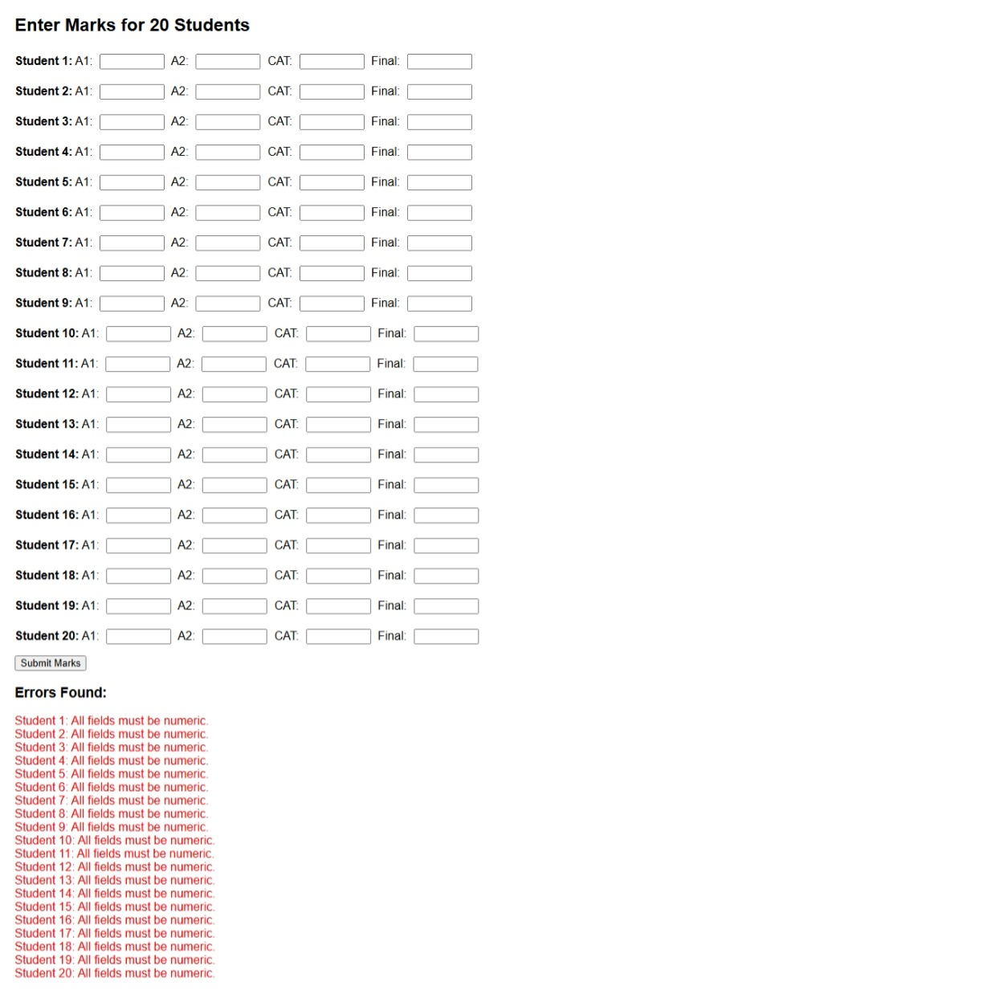

**b) A small company requires that all pages in their web site have a black background, Font size 26, Font family Tahoma, H1 color green, Paragraph margin-left, 50px,Hr yellow, all links be color blue and all visited links be color green.**

**Design a sample solution for the company include example we pages to demonstrate your proposed solution to the company’s management. 15 marks**

index.html file

<!DOCTYPE html>

<html lang="en">

<head>

  <meta charset="UTF-8">

  <title>Welcome Page</title>

  <style>

    body {

      background-color: black;

      font-size: 26px;

      font-family: Tahoma, sans-serif;

      color: white;

    }

    h1 {

      color: green;

    }

    p {

      margin-left: 50px;

    }

    hr {

      border: 1px solid yellow;

    }

    a:link {

      color: blue;

    }

    a:visited {

      color: green;

    }

  </style>

  <script>

    window.onload = function() {

      let userName = prompt("Welcome! Please enter your name:");

      if (userName) {

        document.getElementById("welcome").innerText = "Hello " + userName + ", welcome to our website!";

      } else {

        document.getElementById("welcome").innerText = "Welcome to our website!";

      }

    };

  </script>

</head>

<body>

  <h1>Company Homepage</h1>

  <hr>

  <p id="welcome"></p>

  <p>Explore our services and offerings.</p>

  <p>Visit our <a href="services.html">Services Page</a> for more info.</p>

</body>

</html>

services.html

<!DOCTYPE html>

<html lang="en">

<head>

  <meta charset="UTF-8">

  <title>Our Services</title>

  <style>

    body {

      background-color: black;

      font-size: 26px;

      font-family: Tahoma, sans-serif;

      color: white;

    }

    h1 {

      color: green;

    }

    p {

      margin-left: 50px;

    }

    hr {

      border: 1px solid yellow;

    }

    a:link {

      color: blue;

    }

    a:visited {

      color: green;

    }

  </style>

</head>

<body>

  <h1>Our Services</h1>

  <hr>

  <p>We offer web design, digital marketing, and IT consulting.</p>

  <p><a href="index.html">Back to Home</a></p>

</body>

</html

**The Pages**

